# LITERATURE SURVEY

A literature review surveys books, scholarly articles, and any other sources relevant to a particular issue, area of research, or theory, and by so doing, provides a description, summary, and critical evaluation of these works in relation to the research problem being investigated.

# Project Statement

Due to the ignorance of healthy food habits, obesity rates are increasing at an alarming speed, and this is reflective of the risks to people’s health. People need to control their daily calorie intake by eating healthier foods, which is the most basic method to avoid obesity. However, although food packaging comes with nutrition (and calorie) labels, it’s still not very convenient for people to refer to App-based nutrient dashboard systems which can analyze real-time images of a meal and analyze it for nutritional content which can be very handy and improves the dietary habits, and therefore, helps in maintaining a healthy lifestyle.

This project aims at building a web App that automatically estimates food attributes such as ingredients and nutritional value by classifying the input image of food. Our method employs **Clarifai's AI-Driven Food Detection Model** for accurate food identification and Food API's to give the nutritional value of the identified food.

# Work Flow of the Project

* User interacts with the Web App to Load an image.
* The image is passed to the server application, which uses Clarifai's AI-Driven Food Detection Model Service to analyze the images and Nutrition API to provide nutritional information about the analyzed Image.
* Nutritional information of the analyzed image is returned to the app for display.

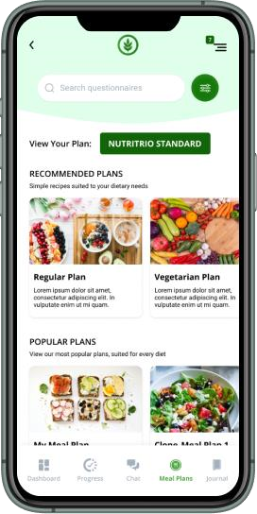

# Reference

https://www.researchgate.net/publication/348459867_Dietitian_assist ant_opportunities_within_the_nutrition_care_process_for_patients_wit h_or_at_risk_of_malnutrition_a_systematic_review <https://smartinternz.com/guided-project/nutro-assistant>

# Conclusion

In this article, we discussed all the aspects of Health & Fitness applications. Straight from the different app ideas, must have features, ways to monetize the app, and the Cost of app development we covered it all. As discussed earlier, there are few existing apps that are doing well. However, they are a few cons that those apps have. To succeed you must study these cons and come up with an app which can resolve all those issues. To achieve all this, you would require the help of a mobile application development firm that can deliver it in minimal cost. Peerbits comprises a pool of talented professionals who would deliver all your requirements with their top-notch skills combined with our cutting-edge technology.